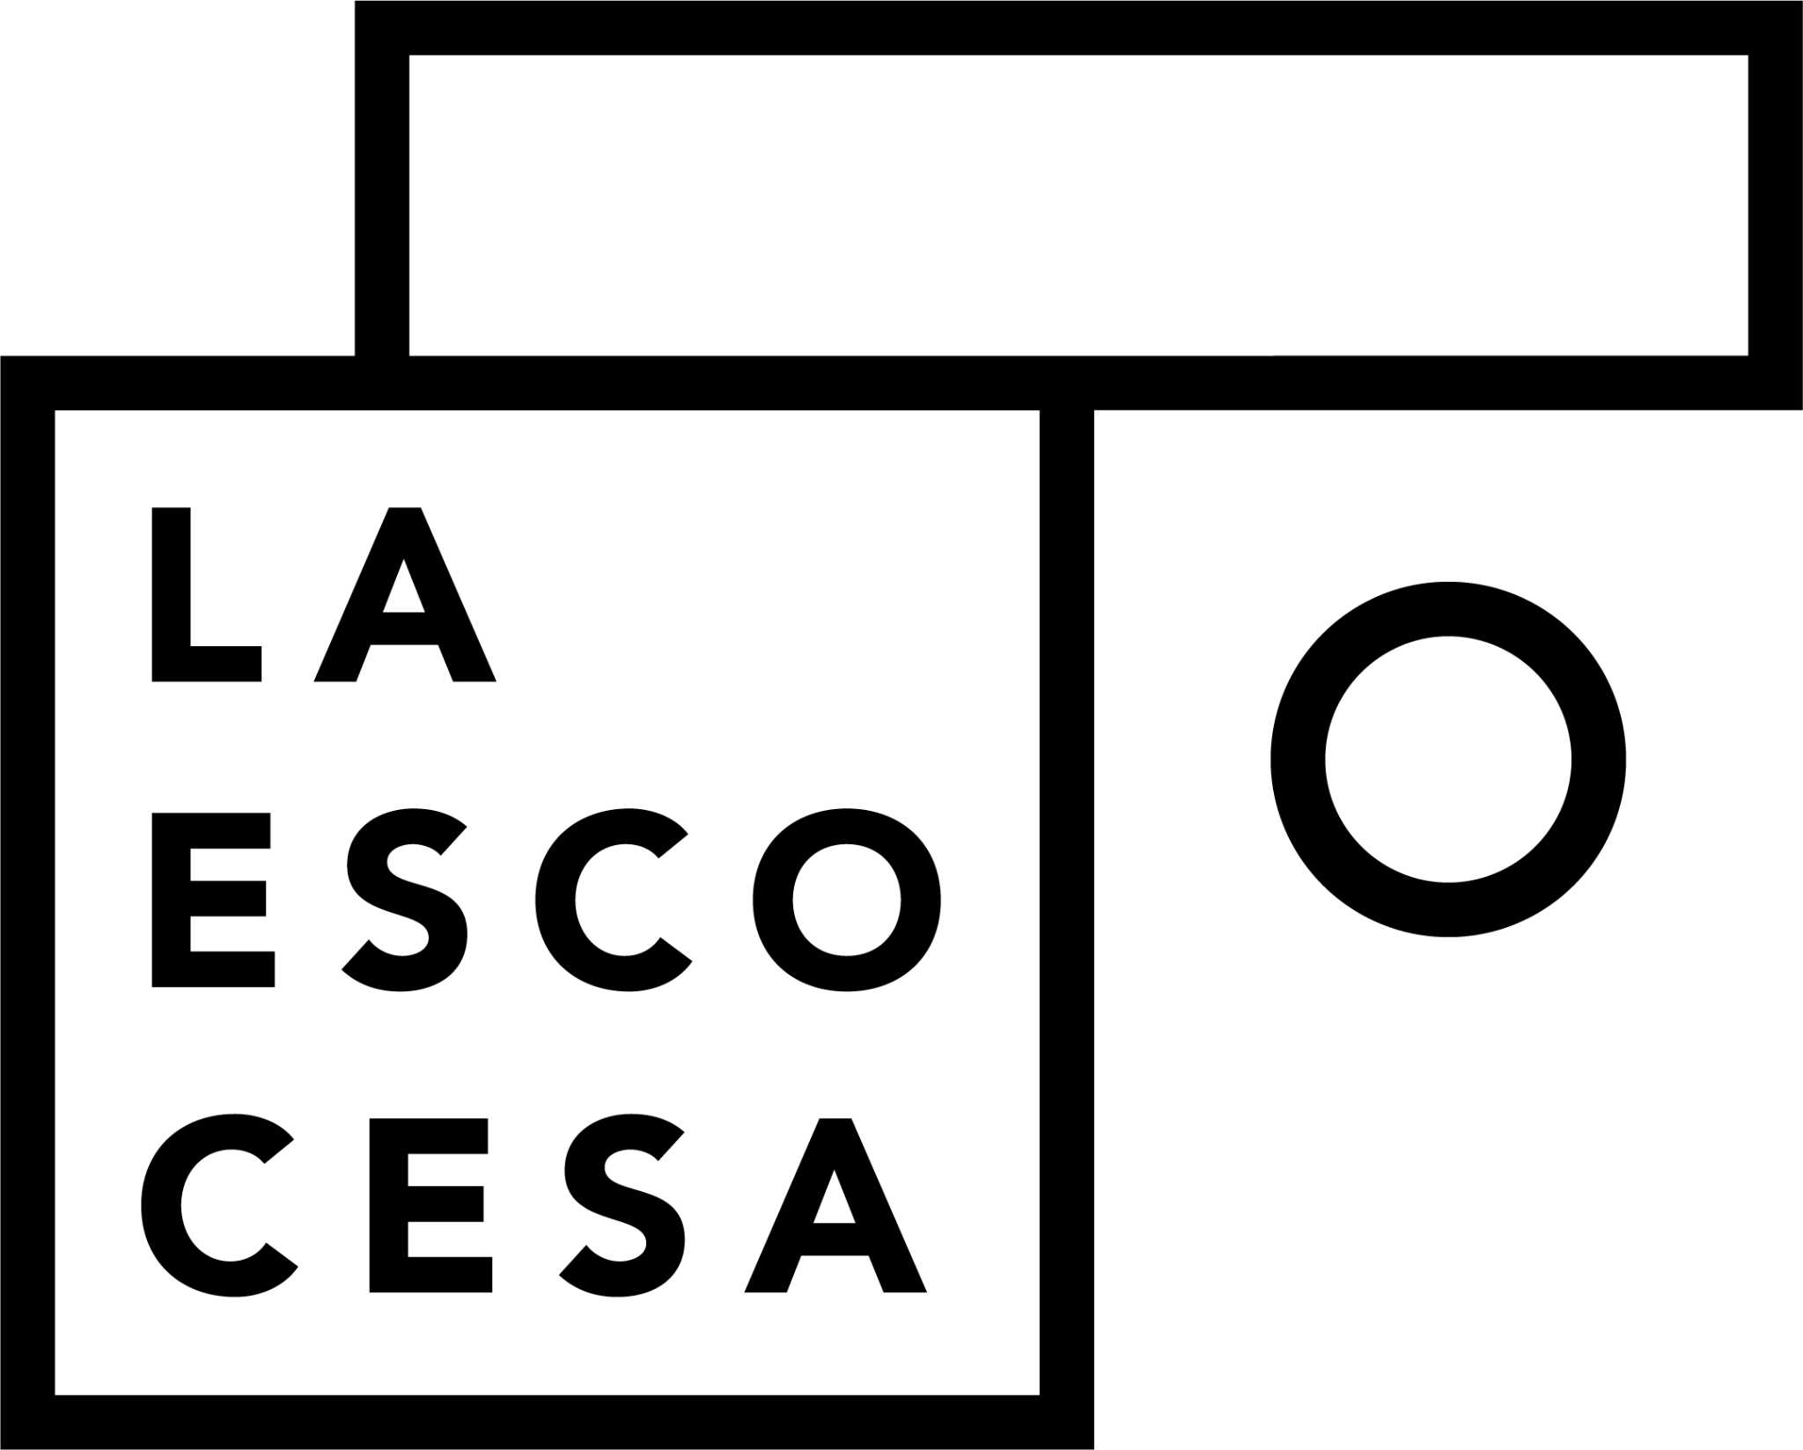
OPEN CALL FORM
FOR ARTISTIC RESIDENCES
LA ESCOCESA 2022

Personal data:

Name and surname with pronoun
Date of birth
Postal address
E-mail
Telephone

Indicate individual ▢ or collective ▢

Types of residence:

Select an option:

- Creation residence
▢ A1. Creation residencies - 1 year (New incorporations)
▢ A2. Creation residencies - 2 years (Current residents)

- Research
▢ B. Research residency - 1 year

To apply to the call, this form must be filled out followed by the documentation mentioned in the bases and sent in a single file in PDF to convocatories@laescocesa.org before October 14, 2022 at 11:59 p.m. with the subject “Residences 2022” and the chosen modality.

The file will be named with the name and surname of the requesting person or group and can be sent in Catalan, Spanish or English. In the case of groups, there must be a representative. Those incomplete applications, that do not include a single file of maximum 5MB or exceed 7 pages will be rejected.

